Frank Gasparro after Sean Melican

PUT NUMBER IN BOX

1, Ea1

2.Ea2

3. H2 + ICl

4. HCl +Cl

5. ∆ H rxn

6. HI + ICl

7. HCl + I2

8. _____________ Fill in

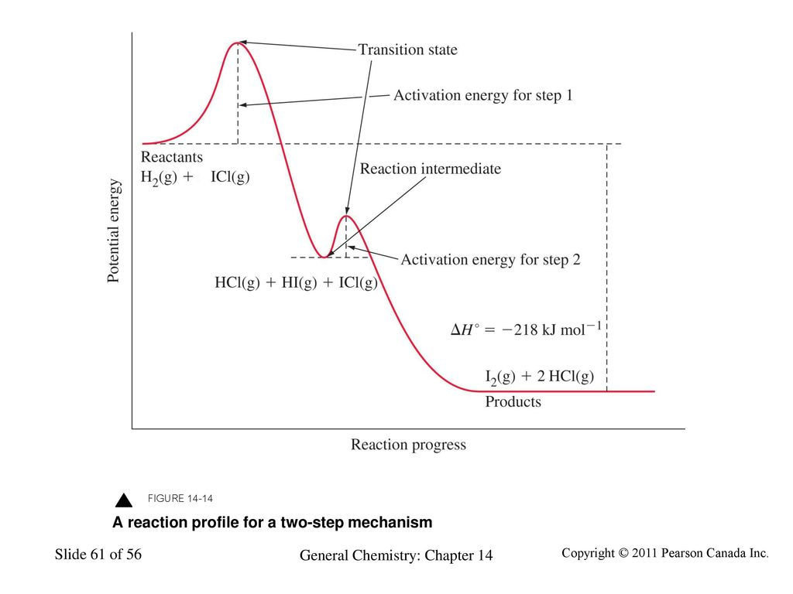



Part I. The reaction mechanism below is for the reaction profile above.

Step 1: H2 + ICl 🡪 HCl + HI

Step 2: HI + ICl 🡪 HCl + I2

1. What is the overall balanced reaction?
2. Based on the reaction profile, identify the slow step.
3. Justify your answer to (b)
4. Based on the proposed mechanism what is the rate law?
5. Determine the sign of enthalpy for step 1 and step 2. Justify your answer.

Part II. The boiling points of some of the compounds are listed below:

ICl: 97 °C

HCl: -85 °C

HI: -35 °C

I2: 184 °C

1. Identify the intermolecular forces in I2 and ICl. Explain why the boiling point of I2 is higher than ICl. Cite types of particles and IMF for both I2 and ICl
2. Identify the intermolecular forces in HI and HCl. Explain why the boiling point of HI is higher than HCl.

Part III. HI is formed by the reaction of H2 and I2 according to the balanced equation:

H2(g) + I2(g) ⇄ 2HI(g)

At 450oC, the Kp value for this reaction is 50.

1. Write the Kp expression.
2. A rigid 1.0 L vessel initial has a pressure of 1 atm of H2 and 1 atm of I2. Calculate the final pressure of HI.
3. How many moles of I2 remain after the reaction has come to equilibrium?